**Chat bot to shop for essentials during pandemic using Watson Assistant**

**INTRODUCTION**

* 1. ***Overview***

With the world facing the pandemic situation of Covid-19, products are essential to help the customers in procuring essential products like vegetables, fruits, and other consumables. The application-based purchase interfaces lack the human touch of interactive dialog while selecting and purchasing the products. In such a scenario, software product like chat bots play a pivotal role in helping customers, shop for essentials with interactive dialogue and help the store owners in understanding customer needs by populating required fields in the database.

* 1. ***Purpose***

The main purpose of this chat bot is to help the customers who visit the stores virtually and help the customers in understanding products, visiting offers, placing orders, and making payments with ease of an interactive dialog. The product provides details about the offers, specials items of the day and takes orders from customers.

**LITERATURE SURVEY**

***2.1*** ***Existing Problem***

Due to Covid-19 pandemic it has become very difficult for all of us to go to the supermarket and purchase the required essentials which increases the risk of getting infected. This has increased the demand for online shopping of essentials. Due to lack of manpower it has become even more difficult for shops/malls to handle its customers and their queries. So, there is a need for a system which will automatically handle various queries of the customers in a proper and efficient manner.

***2.2 Proposed Solution***

A chat bot is designed in such a way that it interacts with the customers, answers their queries, takes order, and sends email to the customers regarding the confirmation of their booking.

This chat is having the following capabilities:

1. Initially bot greets the customer and asks the details
2. The bot takes details like name, contact number, and email id
3. Give the list of items in the Store
4. Shows the prices of vegetables also able to display the offers, discounts, and special items.
5. Able to take the order and mode of payment.

**Services Used:**

1. IBM Watson Assistant
2. Node-Red

**Architecture:**

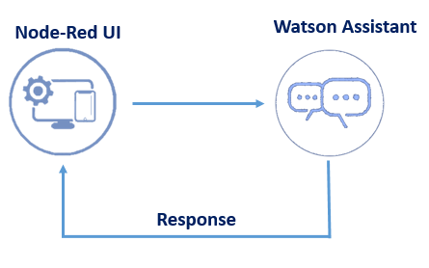

The bot that is designed consists of

1. **Intents**
2. Enquiry
3. Greetings: Greetings where bot will welcome its customer.
4. Order

**Screen Shot: Intents**

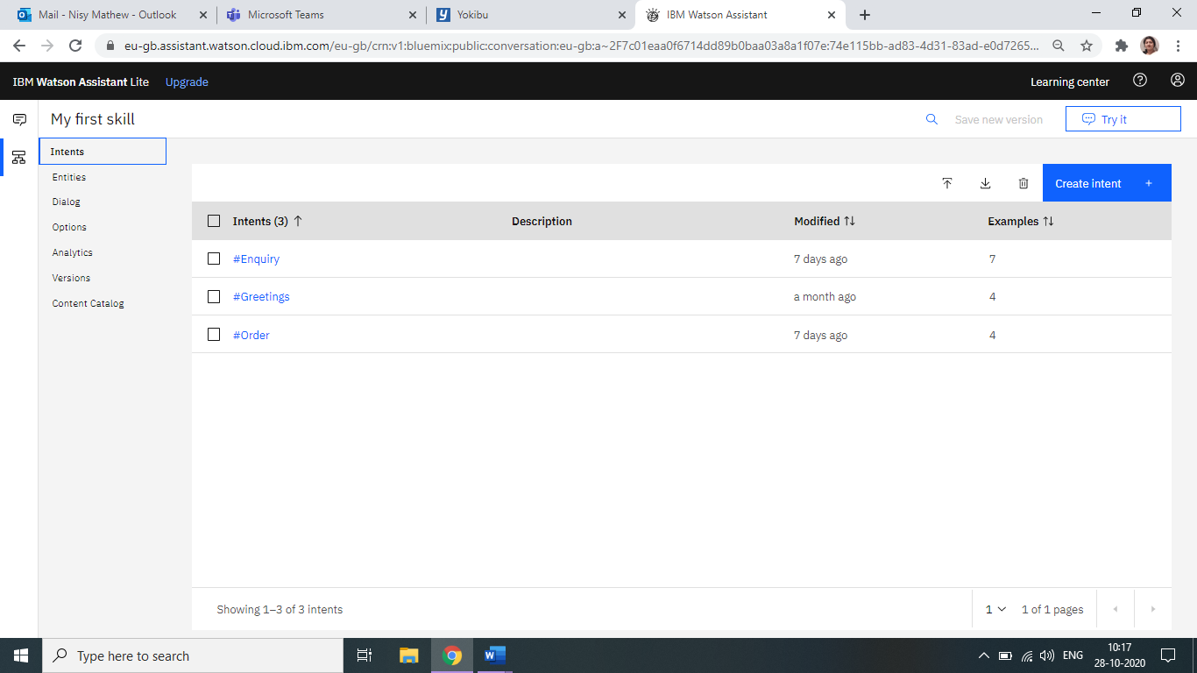

1. **Entities:**
2. Greetings
3. Name of the customer
4. Email ID
5. Contact Number
6. Enquiry
7. Order
8. List to display the specials and Fruits of the day
   1. Specials (Child Node)
      1. Pillsbury atta
      2. Ashirwad atta
      3. Annapurna Atta
   2. Fruits (Child Node)
      1. Apples
      2. Grapes
      3. Oranges
9. Payment to know the payment method of the customer and work accordingly
   1. COD
   2. UPI
   3. Card
10. Provide contact Number
11. Thank you message from the Bot.

**Screen Shot: Entities**

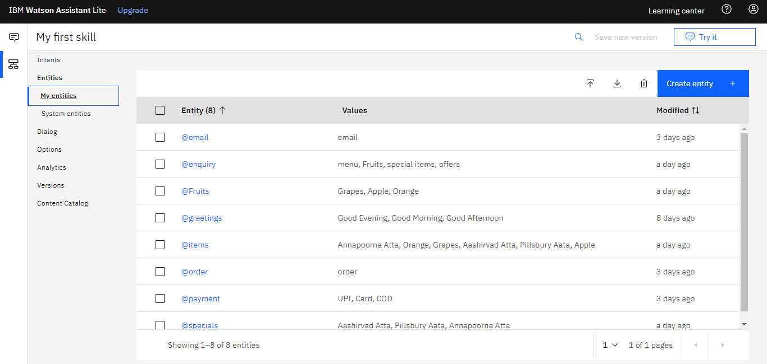

1. **Dialog – with the following nodes**

Welcome Node

Name

Email ID

Greetings Node

Enquiry Node

Order Node

Anything Else Node

**Screenshot: Dialog – with the following nodes**

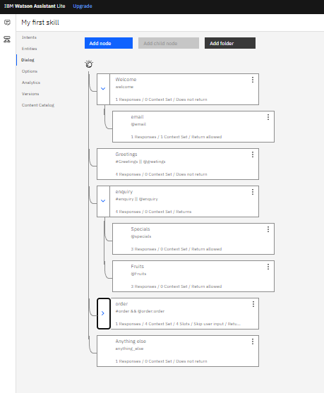

**Integrate Chatbot with Node Red**

1. Open the Node-RED flow created earlier
2. Add another flow with the following connection sequence of nodes and connect the output of the node to the input of the next node. Following nodes are created in Node Red-
3. Inject
4. form
5. function
6. Assistant
7. function
8. Debug
9. 2 text nodes

The flow is shown below-

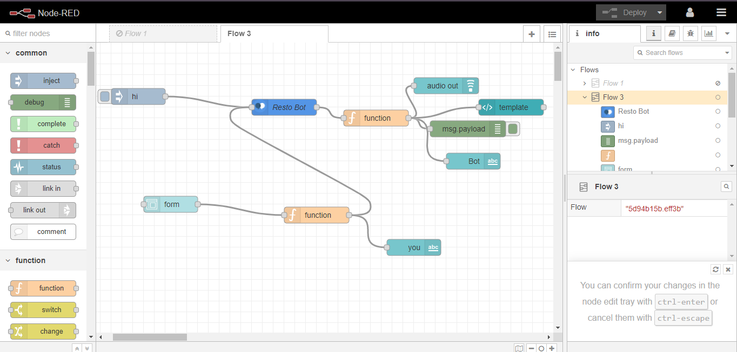

**Output with Node Red integration:**

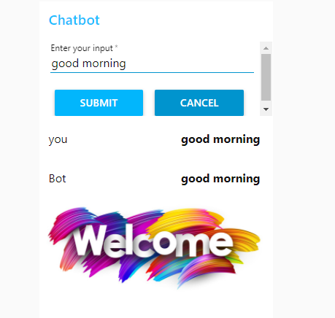

**Conclusion:**

The above designed **Essential MY BOT** can greet, show the item list, and take orders from the customer. The chatbot is also taking Name, email id and contact number for reference.